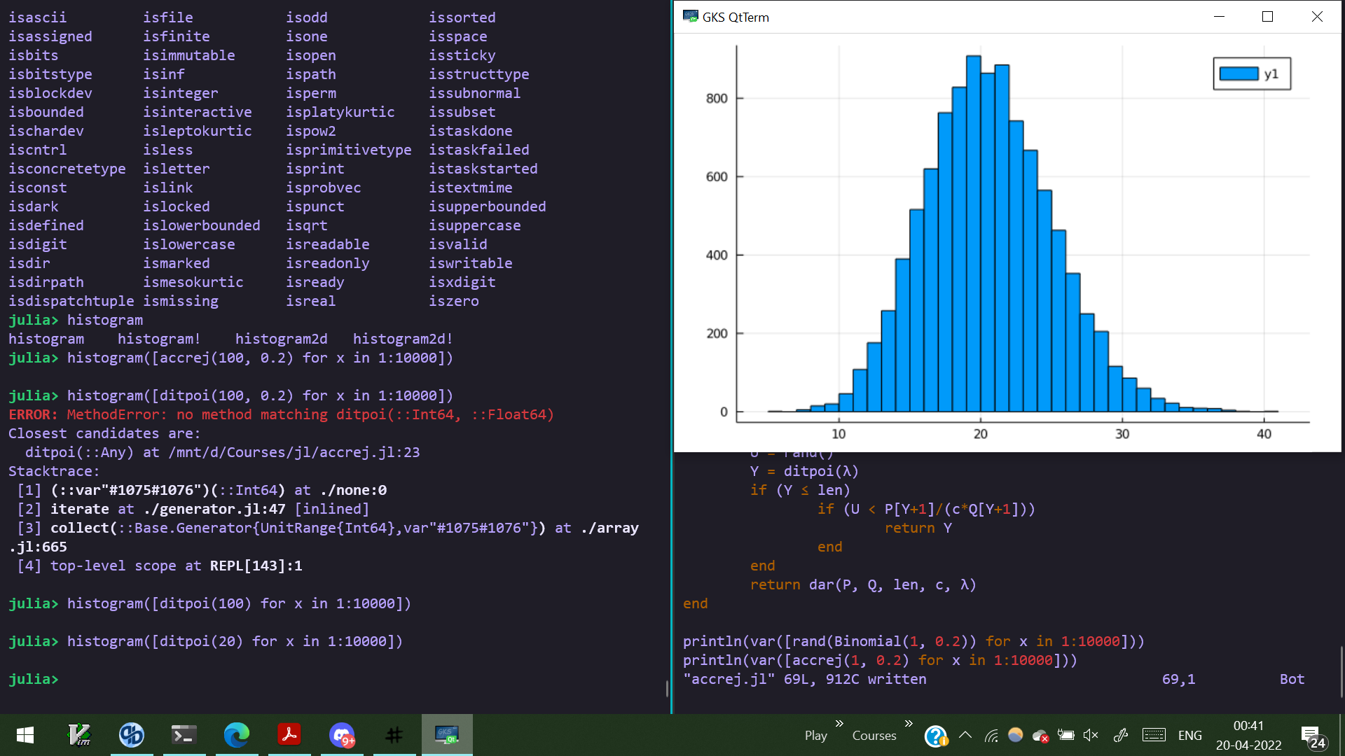

Poisson distribution with lambda = 20

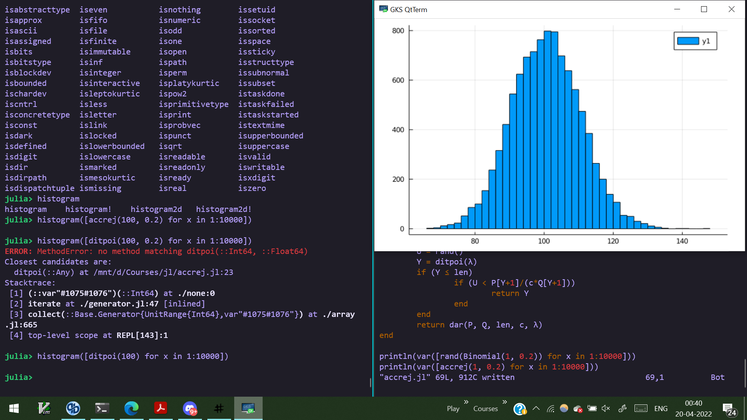

Poisson distribution with lambda = 100

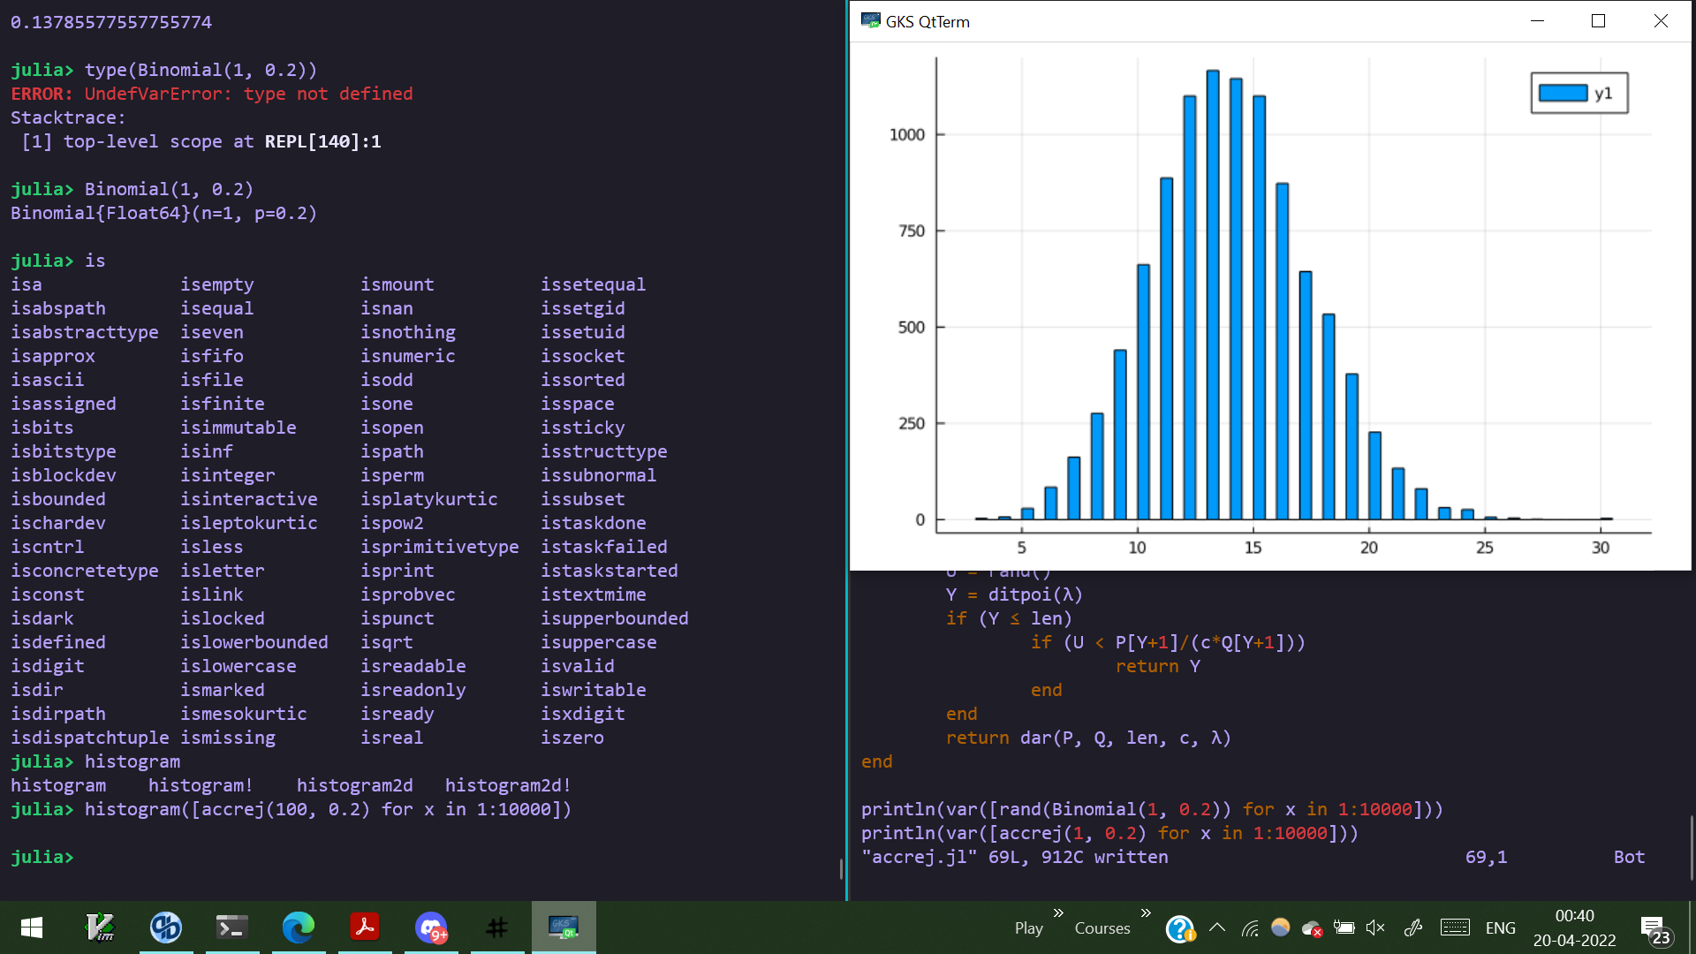

Binomial(n,p) distribution with n = 100 and p = 0.2